Name:

** When opening your LAB LINKS, it is always best to use Firefox or Internet Explorer.

Using a Microscope
Pre-lab Instructions/Questions
Below in numerical order are the instructions to follow in order to complete the prelab for this assignment. Please be sure to read all instructions.

Watch Joelle in the video to learn how scientists focus a microscope. http://www.udel.edu/Biology/ketcham/microscope/testFLV8.html
You may use the microscope provided to you from k12, if you would like to follow along with her. (Note: your microscope is different than the one in the video, so it will not have all the parts Joelle discusses.)
- Open this link: http://www1.udel.edu/biology/ketcham/microscope/scope.html . This is the link for the Virtual Microscope you will be using to complete this LAB assignment.
- Once the Virtual Microscope page is opened, click on the “Getting Started, Start Tour” button to review the functions of the microscope. FOLLOW ALL DIRECTIONS IN THE TOUR! (Note: Make sure the volume of your computer is turned up.)

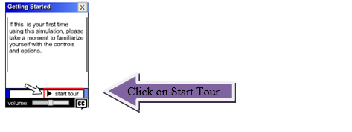
- ANSWER THERE QUESTIONS AS YOU FOLLOW THE TOUR!
  - What objective lens power should you always start with? Highlight the correct answer.
4x (scanning lens) 10x (low power) 40x (high power)

  - Which focus knob moves the stage quickly?
  - Which focus knob moves the stage slowly?
  - Which button do you press to look through the virtual microscope?

  - Were you able to adjust the ocular lenses so you merged the two circles?
  - Where should the center of the specimen be?
  - Write a hypothesis about the focus of the specimen and changing between the powers of the lenses. (Remember: if/then statements!!)

Lab Instructions

THIS IS A CHECKLIST OF TASKS! As you examine each of the 4 virtual microscope slides, use the chart below to help you go through the steps. ** This table is used as a way to check off each task as you look through the microscope slides**
 | Onion | Bacterial
“e” | Root Tip | Capsule | Cheek Smear

Task
1. |  |  |  |  | Turn on microscope light
2. |  |  |  |  | Move the rheostat to 10 (light brightness).
3. |  |  |  |  | Choose the slide in upper right hand corner.
4. |  |  |  |  | Make sure scanning lens is in place (4x)
5. |  |  |  |  | Center the specimen on the stage using the knobs on the right hand side (top) of the microscope.
6. |  |  |  |  | Move stage to top position using the knobs on right hand side (bottom).
7. |  |  |  |  | Click on “switch views” at top of checklist.
8. |  |  |  |  | Adjust the ocular lenses using the eyepieces at top by dragging until circles overlap.
9. |  |  |  |  | Using the coarse adjustment, focus the specimen
10. |  |  |  |  | Then use the fine adjustment to focus more precisely. (The RED circle should be focused)
11. |  |  |  |  | Adjust lighting using iris diaphragm, if needed. (so check appears)
12. |  |  |  |  | Change between the four objective lenses using the rotating nosepiece in bottom left corner.
13. |  |  |  |  | Once finished with this slide, move on to next slide by switching views.
Lab Questions: (The pictures below are examples of how your slides should look when you have correctly focused your microscope)
- How does the letter ‘e’ appear under the microscope?

- Describe what the onion root tip looks like under the 40x lens.

- Describe what the bacterial capsule looks like under the 10x lens.

- Describe what the cheek smear looks like under the 40x lens.

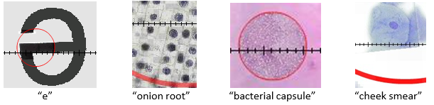
- Determining Total Magnification: The eye piece (ocular lens) you “looked” through on the virtual microscope had a power of 10x. If you were using the 4x objective lens, what would the total magnification before the specimen you are viewing? Show your work!!

- In part ‘g’ of the prelab, you stated a hypothesis. Was your hypothesis correct? Explain.

